Note:- ZUUL is deprecated as on spring Boot > 2.5, use Spring cloud gateway as an alternate to this

Lets say , u want to authenticate each call to microservice from another micro service

API Gateway can take care of common features like authentication like Zuul

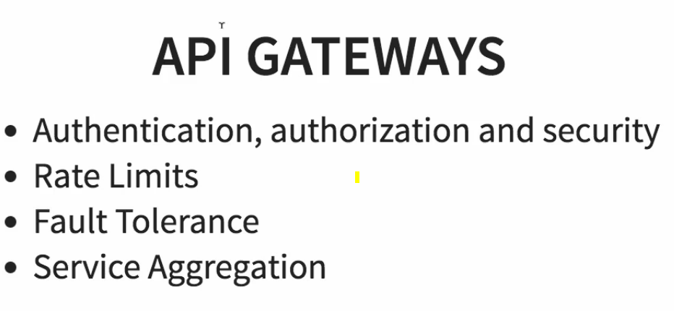all these can be implemented in API Gateways

# Configure Zuul API gateway to log all requests

Create a separate component for the api gateway stuff

Add the below annotation

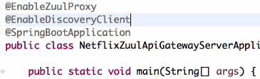

1. Configure application name using

Spring.application.name=nsdj something

Create a filter and extend as below

import com.netflix.zuul.ZuulFilter;

import com.netflix.zuul.context.RequestContext;

@Component

public class ZuulLoggingFilter extends ZuulFilter{

private Logger logger = LoggerFactory.getLogger(this.getClass());

@Override

public boolean shouldFilter() {

return true;}

@Override

public Object run() {

HttpServletRequest request =

RequestContext.getCurrentContext().getRequest();

logger.info("request -> {} request uri -> {}",

request, request.getRequestURI());

return null;

}

@Override

public String filterType() {

return "pre"; //only this will fire before request reaches destination

}

@Override

public int filterOrder() {

return 1;

}

}

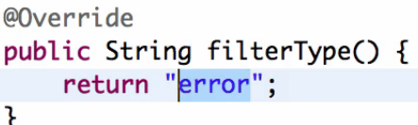

In the above case only errors will be intercepted

# **Principle- How to ensure requests going via API gateway**

If u call direct appn , the requests wont go via api gateway,

So don’t call direct app , instead call api gateway with destination url, in below 8765 is the API gateway url, then

API gateway will re-direct u to go to the desired application

So Zuul is completely dependent on naming server.



In above appn name is the name of the app u want to call.



In above 8765 is the api gateway URL and currency-exchange-service Is the name of the appn u want to call remaining is the url of that controller method

### **How API Gateway knows the target appn URL**

In the above case, we are not calling the direct appn, we are calling API gateway, since all appns are eureka clients, it will take the Appn name (currency-exchange-service) and goes to the Eureka server and get the least load balanced url, and that’s how it api gateway will talk to the target appn

There fore with above approach we will be talking from currency –conversion to currency-exchange via API gateway url.

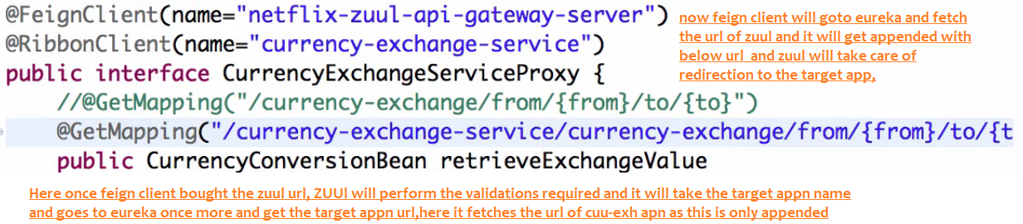

In the above scenario, feign client will go to eureka server and get the url of zuul api gateway, because you have the annotation @FeignClient(“netflix-zuulapi-gateway---”)

Here once feign client bought the zuul url, ZUUl will perform the validations required and it will take the target appn name

and goes to eureka once more and get the target appn url, here it fetches the url of

currency-exchange appn as this is only appended

### **Debugging Problems with Zuul API Gateway**

Using **Chrome Browser**is recommended.

<https://github.com/in28minutes/in28minutes-initiatives/tree/master/The-in28Minutes-TroubleshootingGuide-And-FAQ#debugging-problems-with-zuul-api-gateway>

